Mock Clinical Trial
Background and Rationale
Chronic lymphocytic leukaemia (CLL) is characterised by the accumulation of mature clonal B lymphocytes¹. Disease development depends on two main survival pathways. First, CLL cells rely on continuous B cell receptor signalling, where Bruton’s tyrosine kinase (BTK) promotes proliferation and survival within lymphoid tissues¹. Second, CLL cells avoid apoptosis through overexpression of the anti-apoptotic protein BCL2¹. These pathways provide a clear rationale for combining BTK inhibitors with BCL2 inhibitors¹. Treatment has moved from chemoimmunotherapy to targeted therapy¹. Evidence from recent trials supports the use of BTK inhibitor and BCL2 inhibitor combinations but also highlights mechanistic differences (Figure 1) and important design limitations (Table 1). The CAPTIVATE trial showed that fixed duration ibrutinib plus venetoclax (I+V) produces deep responses (complete response (CR) ~55–56%, peripheral blood undetectable measurable residual disease (uMRD) ~77%)² ³. CAPTIVATE demonstrated that patients achieving uMRD can stop treatment without early relapse². However, CAPTIVATE had short follow-up and included mainly younger patients, limiting conclusions on long-term durability and generalisability². GLOW confirmed efficacy in older and comorbid patients (hazard ratio (HR) for progression-free survival (PFS) 0.216; 24-month PFS 84.4%) and showed that a BTK inhibitor lead-in reduces tumour lysis syndrome risk³, but its population and comparator are less relevant to fitter first-line patients. The FLAIR trial showed that MRD-guided treatment improves outcomes compared with chemoimmunotherapy⁴. This supports response-based treatment, as patients clear disease at different rates and fixed duration may lead to over- or under-treatment⁴. However, FLAIR used ibrutinib, which has higher cardiovascular toxicity, and compared against FCR, which is no longer standard⁴. It therefore does not show whether MRD-guided treatment is superior to modern targeted therapy. The AMPLIFY trial showed that acalabrutinib plus venetoclax (AV) improves safety while maintaining efficacy⁵ but did not test MRD-guided stopping and used chemoimmunotherapy as a comparator⁵. This study addresses these limitations by directly comparing fixed duration and MRD-guided AV using a second-generation BTK inhibitor (acalabrutinib) with greater kinase selectivity and reduced cardiovascular toxicity, within a clinically relevant design to determine whether treatment can be personalised without compromising effectiveness. MRD-guided therapy may reduce unnecessary treatment exposure by allowing therapy to stop once deep remission is achieved, thereby limiting cumulative toxicity and improving the overall cost–benefit balance for patients who may not require indefinite treatment.
Drug Mechanism, Dosing, and Safety Analysis
This trial uses acalabrutinib and venetoclax in CLL. Acalabrutinib inhibits BTK, blocking BCR signalling and redistributing CLL cells from lymph nodes into blood¹. Venetoclax inhibits BCL2 and induces apoptosis (Figure 1E)¹. Acalabrutinib reduces tumour burden and increases sensitivity to venetoclax². Acalabrutinib is given at 100 mg twice daily with a three-cycle lead-in to reduce tumour burden and lower tumour lysis syndrome risk² ³. Venetoclax is then introduced with a five-week dose escalation to 400 mg daily² ³. This approach is based on previous trials showing improved safety with BTK inhibitor lead-in³. The safety profile is better than ibrutinib-based regimens, particularly for cardiovascular toxicity⁵. In AMPLIFY, grade ≥3 hypertension occurred in 2.7% and atrial fibrillation in 0.7%⁵. Common adverse events include neutropenia, infections, and diarrhoea² ⁵, with neutropenia the most frequent grade ≥3 toxicity⁵. MRD-guided treatment may require longer exposure in some patients, making cumulative toxicity relevant⁴. Using acalabrutinib reduces this risk and supports prolonged treatment when needed⁵.

Study Design
This is a phase 3, multicentre, randomised, open-label superiority trial in treatment-naïve CLL. Patients meeting iWCLL criteria will be stratified by IGHV and TP53 status¹ and randomised 1:1 to fixed-duration AV (14 cycles) or MRD-guided AV. Approximately 500 patients (~250 per arm) will be recruited. Randomisation is required to compare treatment duration strategies. Using the same regimen removes confounding and isolates the effect of MRD-guided stopping⁴. An open-label design is mandatory due to the adaptive nature of the MRD-guided arm, which necessitates real-time clinical decisions. To mitigate the risk of observer bias, the primary endpoint (PFS) will be assessed by a central, blinded Independent Review Committee (IRC) using standardised 2018 iWCLL criteria⁴.
Eligibility Criteria
Eligible patients must be adults aged 18 years or older with treatment-naïve CLL requiring therapy according to iWCLL criteria¹. Patients must have ECOG performance status 0–2 and adequate organ function, including haemoglobin >80 g/L, neutrophils >1 × 10⁹/L, platelets >75 × 10⁹/L, creatinine clearance >30 mL/min, and adequate liver function¹. Exclusion criteria include prior CLL treatment, Richter’s transformation, active infection, pregnancy, or other malignancies requiring systemic therapy¹. Patients with significant cardiovascular disease or high bleeding risk are excluded⁵. Patients with recent stroke, myocardial infarction, uncontrolled arrhythmias, active anticoagulation, or severe renal impairment are excluded due to increased risk of BTK inhibitor toxicity and venetoclax-associated TLS² ⁵. These criteria ensure a uniform population, enhancing the homogeneity of the cohort and reducing confounding variables that could otherwise obscure treatment response or toxicity dynamics.
Study Procedures
All patients receive three cycles of acalabrutinib lead-in followed by a five-week venetoclax ramp-up² ³. The fixed-duration arm receives 14 cycles and stops treatment⁵. The MRD-guided arm continues until confirmed uMRD (<10⁻⁴ on two tests ≥3 months apart) with bone marrow confirmation⁴. Patients remain on study until progression, toxicity, withdrawal, or termination. Stratification by IGHV and TP53 is maintained in analysis¹. Confirmed uMRD reduces the risk of stopping based on transient results⁴. MRD-guided treatment may prolong therapy in some patients, requiring close toxicity and quality of life monitoring⁴.
Outcome Measures and Objectives
The primary endpoint is progression-free survival (PFS) comparing fixed-duration and MRD-guided treatment⁴. PFS is chosen because overall survival requires longer follow-up and may be confounded by subsequent therapies⁴. Secondary endpoints include overall survival, MRD negativity rates, MRD kinetics, overall response rate, and time to next treatment² ⁴. Responses are assessed using 2018 iWCLL criteria with blinded independent central review¹. Patient-reported outcomes and quality of life are included, as the main benefit of MRD-guided treatment may be reduced exposure rather than large survival differences⁴.
Conclusion and Potential Impact
This trial tests whether treatment duration should be fixed or MRD-guided using a modern AV regimen. Current evidence supports both approaches, but no study has compared them within the same regimen² ⁴ ⁵. If MRD-guided treatment maintains disease control while reducing exposure, it supports a personalised approach. If not, fixed duration remains standard. This study directly tests a clinically relevant question that current trials have not addressed and will define whether MRD-guided AV should replace fixed-duration therapy in first-line CLL.

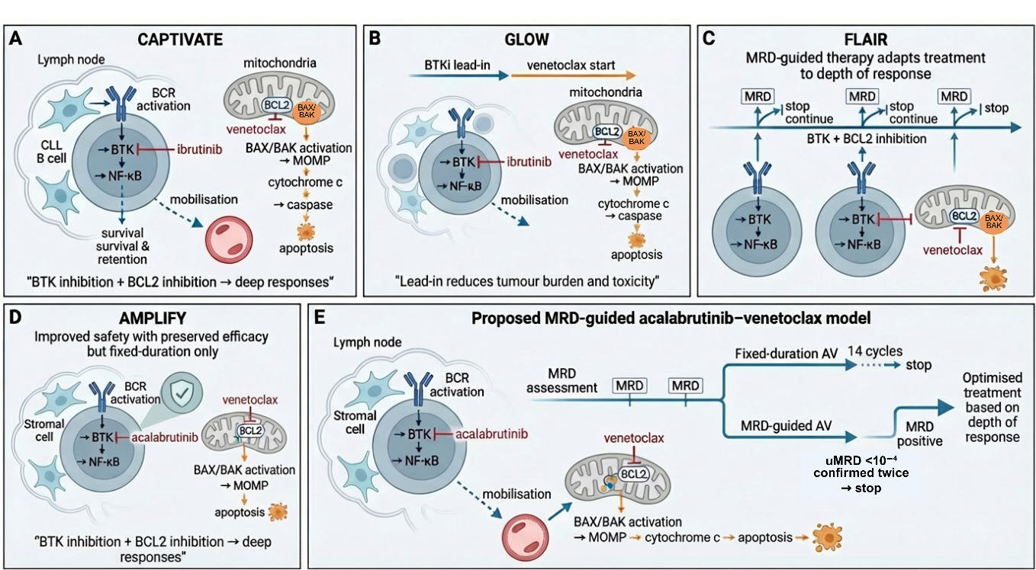
Figure 1. Evolution of Bruton’s tyrosine kinase (BTK) and B-cell lymphoma 2 (BCL2) inhibitor strategies in chronic lymphocytic leukaemia (CLL) and proposed measurable residual disease (MRD)-guided acalabrutinib–venetoclax model. (A) CAPTIVATE shows that ibrutinib plus venetoclax induces deep responses by inhibiting B cell receptor signalling and triggering mitochondrial apoptosis². (B) GLOW demonstrates that ibrutinib lead-in reduces tumour burden and improves venetoclax safety³. (C) FLAIR introduces MRD-guided ibrutinib–venetoclax, where treatment duration is adapted to depth of response⁴. (D) AMPLIFY shows that acalabrutinib improves safety while maintaining efficacy with venetoclax but remains fixed-duration⁵. (E) The proposed trial uses acalabrutinib to disrupt microenvironment-driven survival and mobilise CLL cells, combined with venetoclax-induced BCL2 inhibition and apoptosis, and compares fixed-duration with MRD-guided therapy (undetectable MRD <10⁻⁴ confirmed twice) to optimise treatment duration and reduce toxicity. Adapted from ²⁻⁵. Created in BioRender.com.
Abbreviations: BCR; B cell receptor, BTK; Bruton’s tyrosine kinase, BTKi; Bruton’s tyrosine kinase inhibitor, BCL2; B cell lymphoma 2, BAX/BAK; pro-apoptotic effector proteins, MOMP; mitochondrial outer membrane permeabilisation, MRD; measurable residual disease, uMRD; undetectable measurable residual disease.

Table 1. Comparative analysis of key clinical trials in CLL informing study design. Summary of study design, efficacy outcomes, limitations, and areas for improvement in CAPTIVATE², GLOW³, FLAIR⁴, and AMPLIFY⁵. These trials establish fixed-duration therapy and MRD-guided strategies but highlight the lack of direct comparison using a second-generation BTK inhibitor.
NCT Number | Study name | Study design | Main findings | Main limitations | How to improve it
NCT02910583 | CAPTIVATE FD | • Phase 2, international, open-label  • Single-arm study  • Younger, fit untreated CLL  • three-cycle ibrutinib lead-in + 12 cycles I+V  • Fixed duration | • CR rate 55–56%  • PB uMRD 77%, BM uMRD 60%  • 24-month PFS ~95%  • Lead-in reduces TLS risk from 21% to 1%  • Feasible all-oral regimen | • No comparator arm  • Cannot assess superiority  • Shorter follow-up  • Limited generalisability  • Uses ibrutinib  • Not MRD-guided design | • Add randomised comparator arm  • Compare fixed vs MRD-guided duration  • Use second-generation BTKi  • Extend follow-up for durability
NCT03462719 | GLOW | • Phase 3, randomised, open-label  • Older or comorbid untreated CLL  • Fixed duration I+V vs chlorambucil + obinutuzumab  • Includes BTKi lead-in  • Median follow-up ~27.7 months | • Strong PFS benefit: HR 0.216  • 24-month PFS: 84.4%  • Higher MRD negativity (BM uMRD 55.7% vs 21.0%)  • Demonstrates fixed-duration feasibility  • Lead-in reduces TLS risk | • Older, less fit population  • Weak comparator  • Uses ibrutinib with higher cardiac toxicity  • No clear OS benefit  • Excludes high-risk genetics | • Compare with modern targeted regimens  • Use acalabrutinib instead of ibrutinib  • Extend follow-up for OS  • Include broader risk populations
ISRCTN01844152 | FLAIR | • Phase 3, multicentre, randomised, open-label  • Untreated, fit CLL  • MRD-guided I+V vs FCR  • Adaptive platform design  • Median follow-up 43.7 months | • PFS HR 0.13  • 3-year PFS: 97.2% vs 76.8%  • 3-year OS: 98.0% vs 93.0%  • 58% stopped treatment via MRD  • Long-term MRD negativity ~92.7%  • Strongest MRD-guided evidence | • Longer treatment duration  • Uses ibrutinib with cardiac toxicity  • Comparator FCR less relevant  • Complex MRD-guided design  • Not directly testing AV | • Test acalabrutinib + venetoclax  • Compare MRD-guided vs fixed duration directly  • Shorten treatment duration  • Use modern comparator
NCT03836261 | AMPLIFY | • Phase 3, multicentre, randomised, open-label  • Untreated, fit CLL without del(17p) or TP53 mutation  • 1:1:1 to AV, AVO, or chemo (FCR or BR)  • Fixed duration regimen  • Median follow-up 40.8 months | • 36-month PFS: AV 76.5%, AVO 83.1%, chemo 66.5%  • AV vs chemo: HR 0.65  • 36-month OS: AV 94.1% vs chemo 85.9%  • Highest MRD negativity in AVO  • Lower grade ≥3 neutropenia with AV (32.3%)  • Low atrial fibrillation (0.7%) | • Comparator is chemo, not modern targeted therapy  • Open-label design  • Covid deaths confound OS  • MRD measured before treatment completion  • Not powered for AV vs AVO comparison | • Compare AV vs venetoclax + obinutuzumab or MRD-guided AV  • Harmonise MRD timing at end of treatment  • Use modern targeted comparator  • Power for doublet vs triplet comparison
Abbreviations: CLL; chronic lymphocytic leukaemia, BTKi; Bruton’s tyrosine kinase inhibitor, BCL2; B-cell lymphoma 2, I+V; ibrutinib plus venetoclax, AV; acalabrutinib plus venetoclax, AVO; acalabrutinib plus venetoclax plus obinutuzumab, FCR; fludarabine cyclophosphamide rituximab, BR; bendamustine rituximab, O; obinutuzumab, PB; peripheral blood, BM; bone marrow, uMRD; undetectable measurable residual disease, MRD; measurable residual disease, PFS; progression-free survival, OS; overall survival, CR; complete response, TLS; tumour lysis syndrome, HR; hazard ratio.

Acknowledgements
Figure 1 was created and edited using BioRender.com. General structural guidance was supported by ChatGPT.
References
- Walewska R, Eyre TA, Bloor A, Follows G, Iyengar S, Johnston R, et al. 2025 British Society for Haematology guideline for the treatment of chronic lymphocytic leukaemia. Br J Haematol. 2025;207(6):2296–2313. doi:10.1111/bjh.70100.
- Tam CS, Allan JN, Siddiqi T, Kipps TJ, Jacobs R, Opat S, et al. Fixed-duration ibrutinib plus venetoclax for first-line treatment of CLL: primary analysis of the CAPTIVATE FD cohort. Blood. 2022;139(22):3278–3289. doi:10.1182/blood.2021014488.
- Kater AP, Owen C, Moreno C, Follows G, Munir T, Levin MD, et al. Fixed-duration ibrutinib-venetoclax in patients with chronic lymphocytic leukemia and comorbidities. NEJM Evid. 2022;1(7):EVIDoa2200006. doi:10.1056/EVIDoa2200006.
- Munir T, Girvan S, Cairns DA, Bloor A, Allsup D, Varghese AM, et al. Measurable residual disease–guided therapy in chronic lymphocytic leukaemia. N Engl J Med. 2025;393(12):1177–1190. doi:10.1056/NEJMoa2504341.
- Brown JR, Seymour JF, Jurczak W, Aw A, Wach M, Illes A, et al. Fixed-duration acalabrutinib combinations in untreated chronic lymphocytic leukaemia (AMPLIFY). N Engl J Med. 2025;392(8):748–762. doi:10.1056/NEJMoa2409804.

